Activity-Based Learning Report

BREAST CANCER PREDICTION

Objective: To develop a machine learning model using classification algorithms to predict whether a breast tumor is benign or malignant based on medical diagnostic data. The goal is to support early detection of breast cancer and assist healthcare professionals in making accurate clinical decisions.

Applications Identified:
Application Area | Healthcare / Medical Diagnosis / Cancer Detection
Description | This application uses medical diagnostic features such as radius, texture, perimeter, area, smoothness, compactness, concavity, and symmetry to predict whether a breast tumor is benign or malignant. By applying a machine learning model such as Decision Tree, the system can assist doctors in identifying cancer at an early stage and improving diagnosis accuracy.
ML Type  (Supervised/ Unsupervised/ Semi-supervised) | Supervised Learning

This project aims to identify whether a breast tumor is malignant or benign by analyzing medical diagnostic data collected from patients. Key features such as tumor radius, texture, perimeter, smoothness, compactness, concavity, and symmetry were extracted from the dataset and used to train a Decision Tree Classifier, a supervised machine learning algorithm. The model was able to predict breast cancer with high accuracy by learning patterns from labeled medical data.
The project demonstrates the effectiveness of machine learning in the healthcare domain and emphasizes the importance of data-driven systems in supporting early cancer diagnosis and reducing medical diagnostic errors. Decision Tree classification helps in understanding how different medical attributes contribute to the prediction process through simple decision rules and tree structures.
This system can be applied in hospitals, diagnostic centers, healthcare applications, and medical decision-support systems to assist doctors in predicting breast cancer at an early stage and improving patient treatment outcomes.

Activity 1: Data Preprocessing
Objective
The primary objective of data preprocessing is to transform raw medical data into a clean, structured, and analyzable format by handling inconsistencies, missing values, and irrelevant attributes. This step ensures:
1. Data Quality Improvement
- Handling missing values to improve prediction accuracy.
- Removing duplicate entries to avoid incorrect analysis results.
- Checking for inconsistent or invalid medical records.
2. Feature Selection
- Selecting important medical diagnostic features related to breast cancer prediction.
- Removing unnecessary attributes that do not contribute to classification.
3. Outlier Detection & Handling
- Identifying abnormal values in tumor measurements that may affect model performance.
- Ensuring the dataset contains realistic and medically valid data.
4. Data Transformation
- Converting diagnosis labels into numerical values for machine learning processing.
- Preparing the dataset for Decision Tree classification.
5. Data Splitting
- Dividing the dataset into training and testing sets for model training and evaluation.
Dataset Used
Name: Breast Cancer Dataset
Source: Kaggle / UCI Machine Learning Repository
Dataset : Breast Cancer Wisconsin (Original) - UCI Machine Learning Repository
Initial Data Overview
- Dataset Size:
The original dataset consists of 569 entries (rows), with each row representing the medical diagnostic details of one patient.
- Number of Features:
There are 32 initial features (columns) in the raw dataset:
- ID
- Diagnosis
- Radius Mean
- Texture Mean
- Perimeter Mean
- Area Mean
- Smoothness Mean
- Compactness Mean
- Concavity Mean
- Concave Points Mean
- Symmetry Mean
- Fractal Dimension Mean
- Radius SE
- Texture SE
- Perimeter SE
- Area SE
- Smoothness SE
- Compactness SE
- Concavity SE
- Concave Points SE
- Symmetry SE
- Fractal Dimension SE
- Radius Worst
- Texture Worst
- Perimeter Worst
- Area Worst
- Smoothness Worst
- Compactness Worst
- Concavity Worst
- Concave Points Worst
- Symmetry Worst
- Fractal Dimension Worst
After preprocessing, irrelevant columns such as ID and unnamed attributes were removed. The diagnosis column was converted into numerical values for machine learning processing, where:
- Malignant (M) = 1
- Benign (B) = 0
The cleaned dataset contains only useful medical diagnostic features required for breast cancer prediction using the Decision Tree algorithm.
- Missing Values:
Upon inspection, the dataset was found to be complete with no missing values in any of the columns. Each medical record was valid and suitable for analysis without requiring imputation or data filling techniques.
- Outliers:
Outlier detection was performed on important numerical features using statistical analysis methods to identify abnormal tumor measurement values. The analysis was carried out for attributes including:
- Radius Mean
- Texture Mean
- Perimeter Mean
- Area Mean
- Smoothness Mean
- Compactness Mean
- Concavity Mean
- Symmetry Mean
- Radius Worst
- Area Worst
These outliers were analyzed carefully to avoid distortion in model training and prediction performance. The dataset maintained its integrity after preprocessing, and the cleaned data provided a reliable foundation for accurate breast cancer prediction using the Decision Tree Classifier.
Cleaning Steps Performed
To ensure high-quality medical data for analysis and machine learning, several preprocessing and cleaning steps were performed on the raw breast cancer dataset. These steps are essential for building a reliable prediction model and improving the accuracy of breast cancer diagnosis.

• Handling Missing Values:
The dataset was carefully inspected for missing or null values across all columns. Fortunately, no missing values were found in the dataset. Each of the 569 rows contained complete medical diagnostic information, so no imputation or row removal was necessary during this step.
• Removing/Handling Outliers:
Outliers can affect the performance and accuracy of machine learning models, especially in medical datasets containing numerical measurements.
• Feature Encoding:
The Diagnosis column containing categorical values such as Malignant (M) and Benign (B) was converted into numerical format for machine learning processing.
• Removing Irrelevant Features:
The ID column was removed from the dataset because it does not contribute to breast cancer prediction.
• Normalization/Scaling:
Normalization or feature scaling was not applied during preprocessing because the Decision Tree algorithm can handle different feature value ranges effectively.
Tools Used
The following tools and technologies were used for developing the Breast Cancer Prediction System using the Decision Tree algorithm:
- Python
Used as the primary programming language for implementing the machine learning model and data preprocessing tasks.
- Jupyter Notebook
Used as the development environment for writing, testing, and executing Python code interactively.
- Pandas
Used for data loading, cleaning, preprocessing, and manipulation of the breast cancer dataset.
- NumPy
Used for numerical computations and array operations.
- Matplotlib
Used for data visualization and graphical representation of dataset analysis.
- Scikit-learn(sklearn)
Used for implementing the Decision Tree Classifier, dataset splitting, and model evaluation.
- Breast Cancer Wisconsin Dataset
Used as the dataset for training and testing the breast cancer prediction model.
- Machine Learning Algorithm – Decision Tree
Used for classifying tumors as malignant or benign based on medical diagnostic features.

Challenges Encountered and Solutions
During the development of the Breast Cancer Prediction model using the Decision Tree, several challenges were encountered at various stages of data preprocessing, feature selection, and model training. Each challenge was addressed using appropriate preprocessing techniques and machine learning methods to ensure the reliability and accuracy of the final prediction system.
• Identifying Relevant Features Challenge:
The original breast cancer dataset contained multiple medical attributes, including columns such as ID, which were not useful for prediction. Including unnecessary features could increase model complexity and reduce prediction efficiency.
Solution:
The dataset was carefully analyzed, and irrelevant columns such as ID were removed because they do not contribute to breast cancer diagnosis. Only important tumor measurement features were retained for model training and prediction.
• Handling Medical Diagnostic Data Challenge:
The dataset contained complex numerical medical measurements related to tumor characteristics. Understanding and organizing these diagnostic features for machine learning processing was challenging during the initial stage.
Solution:
The medical attributes were studied carefully, and meaningful features such as radius, texture, perimeter, area, smoothness, compactness, and concavity were selected for analysis. Proper preprocessing helped prepare the dataset for accurate prediction.
• Encoding Categorical Diagnosis Values Challenge:
The Diagnosis column contained categorical text values:
- M (Malignant)
- B (Benign)
Machine learning algorithms require numerical input values and cannot directly process text labels.
Solution:
Label encoding was applied to convert diagnosis values into numerical format:
- Malignant (M) = 1
- Benign (B) = 0
This conversion enabled smooth training and testing of the Decision Tree classifier.
• Managing Outliers in Medical Features Challenge:
Some tumor measurements contained extreme values that could negatively influence the model’s prediction accuracy and create bias during training.
Solution:
Important numerical features were analyzed using statistical methods to identify outliers. The dataset was cleaned carefully while preserving medically important information required for accurate diagnosis.
• Model Accuracy and Overfitting Challenge:
Achieving high prediction accuracy while preventing overfitting was one of the major challenges during model training.
Solution:
The dataset was divided into training and testing datasets to evaluate model performance properly. The Decision Tree model was trained using cleaned and structured data, resulting in accurate classification of malignant and benign tumors.
• Understanding Dataset Feature Values Challenge:
Some medical attributes contained decimal values, creating confusion regarding acceptable input formats for prediction.
Solution:
The dataset was analyzed carefully to understand the value ranges and distributions of all medical features. The system was designed to accept both integer and decimal values where necessary to maintain prediction accuracy.

Activity 2: Data Analysis and Visualization

Objective
The objective of this activity is to explore and visualize the cleaned breast cancer dataset obtained after preprocessing in Activity 1 in order to understand the relationship between medical diagnostic features and breast cancer prediction.
Through various visualizations and analyses, the following goals were achieved:
• Differentiate between malignant and benign tumor cases
• Analyze patterns across important medical attributes such as radius, texture, perimeter,
area and smoothness
• Understand the impact of key tumor features on breast cancer diagnosis
• Identify relationships and variations among diagnostic measurements
This visual analysis helps in gaining meaningful insights from the dataset and supports accurate prediction and model building using the Decision Tree in later stages of the project.
Techniques Applied
To effectively understand and interpret the cleaned breast cancer dataset, several visualization and analysis techniques were applied. These techniques helped in identifying patterns, relationships, and prediction performance related to breast cancer diagnosis. The following are the key techniques used:
• Bar Chart:
Bar charts were used to display the distribution of diagnosis categories such as malignant and benign tumors. This visualization helped in understanding the class distribution within the dataset and identifying whether the dataset was balanced for machine learning training.
• Horizontal Bar Chart:
Horizontal bar charts were used to compare the importance and variation of different tumor features such as radius, texture, perimeter, and area. This technique provided a clear comparison of medical attributes and improved readability during feature analysis.
• Confusion Matrix:
A confusion matrix was generated to evaluate the performance of the Decision Tree model. It displayed the number of correctly and incorrectly classified malignant and benign tumor cases. This technique helped in measuring prediction accuracy, classification errors, and overall model effectiveness.
• Correlation Heatmap:
A correlation heatmap was used to identify relationships between numerical medical features such as radius, perimeter, area, concavity, and smoothness. The heatmap visually represented correlation values between attributes, helping in understanding feature dependencies and selecting important features for breast cancer prediction.

Insights Gained
Through detailed analysis and visualization of the cleaned breast cancer dataset, several important insights were discovered regarding medical diagnostic features and their relationship with breast cancer prediction:
• Tumor Size and Diagnosis:
It was observed that malignant tumors generally have larger values for features such as radius, perimeter, and area compared to benign tumors. This indicates that tumor size-related attributes play an important role in breast cancer diagnosis.
• Texture and Concavity Patterns:
Features related to texture, compactness, concavity, and concave points showed noticeable differences between malignant and benign tumor cases. Malignant tumors tended to exhibit higher irregularity and concavity values.
• Feature Relationships:
The correlation heatmap revealed strong positive relationships between several medical features such as radius, perimeter, and area measurements. Highly correlated features indicated that tumor dimensions are closely connected and significantly influence diagnosis prediction.
• Class Distribution:
The bar chart analysis showed that the dataset contains both malignant and benign tumor cases, helping in understanding the overall class distribution used for machine learning training and testing.
• Model Prediction Performance:
The confusion matrix demonstrated that the Decision Tree model was able to classify most tumor cases correctly. The number of correctly predicted malignant and benign cases was significantly higher than the number of incorrect predictions, indicating good model performance.
• Important Predictive Features:
Medical attributes such as radius mean, perimeter mean, area mean, concavity mean, and concave points mean were identified as highly influential features for breast cancer prediction. These features contributed strongly to distinguishing malignant tumors from benign tumors.
• Visualization-Based Understanding:
The visual analysis techniques helped in understanding patterns within the dataset more effectively. Graphical representations improved interpretation of medical data and supported better feature selection for machine learning modelling.

Visualizations
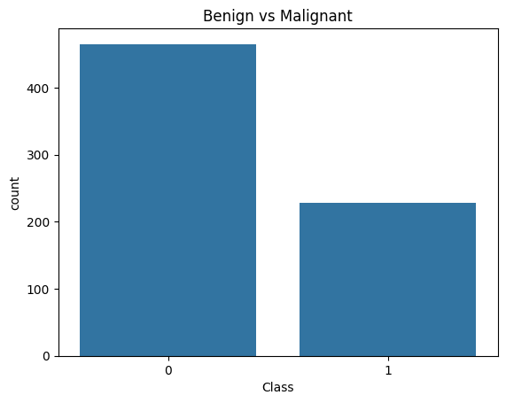
Figure 1.1: Bar Plot – Benign vs Malignant Tumors
The Figure 1.1 shows the distribution of tumor cases classified as either benign or malignant based on medical diagnostic measurements in the breast cancer dataset. The classification is derived from the diagnosis attribute, where:
- Benign tumors represent non-cancerous cases
- Malignant tumors represent cancerous cases
The bar plot helps in understanding the class distribution within the dataset and provides insights into the number of patients belonging to each diagnosis category. This visualization is useful for identifying dataset balance and supporting accurate machine learning model training using the Decision Tree.

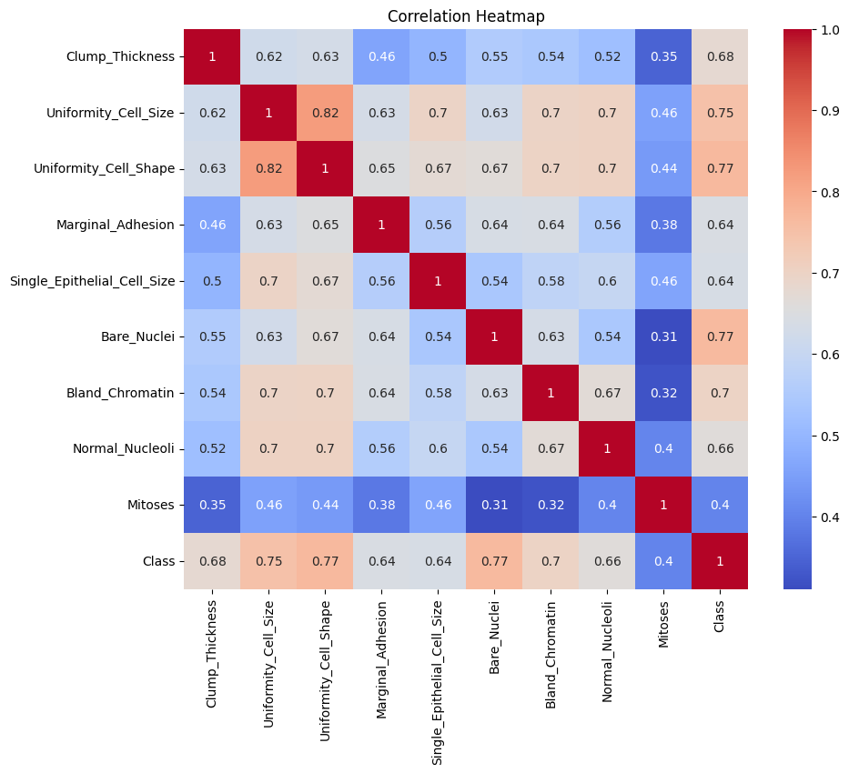
Figure 1.4: Correlation Heatmap
The Figure 1.4 shows the correlation heatmap representing the relationships between different medical diagnostic features used in breast cancer prediction. The heatmap visually displays correlation values between attributes such as radius, texture, perimeter, area, smoothness, compactness, concavity, and symmetry.
Features with strong positive correlation appear closely related and contribute significantly to the classification of benign and malignant tumors. The heatmap helps in identifying feature dependencies, understanding data patterns, and selecting the most important attributes for training the Decision Tree model.
This visualization provides better understanding of the dataset structure and supports accurate breast cancer prediction by highlighting relationships among medical diagnostic features.

course project

BREAST CANCER PREDICTION

Chapter 1
Introduction
In today’s healthcare environment, early detection of breast cancer is extremely important for improving patient survival rates and reducing the risk of severe medical complications. Breast cancer is one of the most common cancers affecting women worldwide, and accurate diagnosis at an early stage can significantly improve treatment outcomes. Traditional diagnostic methods may sometimes be time-consuming and dependent on manual interpretation, creating the need for intelligent and data-driven prediction systems.
This project aims to develop a machine learning-based predictive model to detect breast cancer using the Decision Tree algorithm. The model is trained on a medical diagnostic dataset containing important tumor-related attributes such as radius, texture, perimeter, area, smoothness, compactness, concavity, concave points, symmetry, and fractal dimensions. By analyzing these medical features, the system classifies tumors as either “Malignant” or “Benign,” providing valuable support for accurate breast cancer diagnosis and early medical intervention.

1.1 Background
Breast cancer has become a major health concern due to its increasing occurrence and impact on human life. Early diagnosis plays a critical role in improving treatment success and reducing mortality rates. Traditional diagnostic techniques often depend on manual medical analysis, which may sometimes lead to delays or diagnostic errors.
This project adopts a machine learning approach to predict breast cancer using measurable medical diagnostic features extracted from tumor cell data. Important attributes such as radius, texture, perimeter, area, smoothness, compactness, and concavity help in identifying patterns associated with malignant and benign tumors. The use of machine learning enables faster and more reliable diagnosis based on data-driven analysis.

1.2 Motivation and Problem statement
In modern healthcare systems, there is a growing need for intelligent tools that can assist doctors in detecting diseases quickly and accurately. Breast cancer diagnosis involves analyzing multiple medical parameters, making manual prediction difficult and time-consuming. Therefore, developing an automated prediction system using machine learning can help improve diagnostic efficiency and support healthcare professionals.
The objective of this project is to develop a machine learning-based predictive model using the Decision Tree algorithm to classify tumors as “Malignant” or “Benign” based on important medical diagnostic features such as radius, texture, perimeter, area, smoothness, compactness, concavity, and symmetry. The developed system aims to support early breast cancer detection and improve the accuracy of medical diagnosis through data-driven prediction techniques.

1.3 Objectives
• To develop a machine learning model using the Decision Tree algorithm that predicts whether a breast tumor is malignant or benign based on medical diagnostic features such as radius, texture, perimeter, area, smoothness, compactness, and concavity.
• To analyze and identify the most important medical features contributing to breast cancer prediction, enabling accurate diagnosis and supporting early detection for improved healthcare and treatment outcomes.

Chapter 2
Model Development
2.1 Methodology
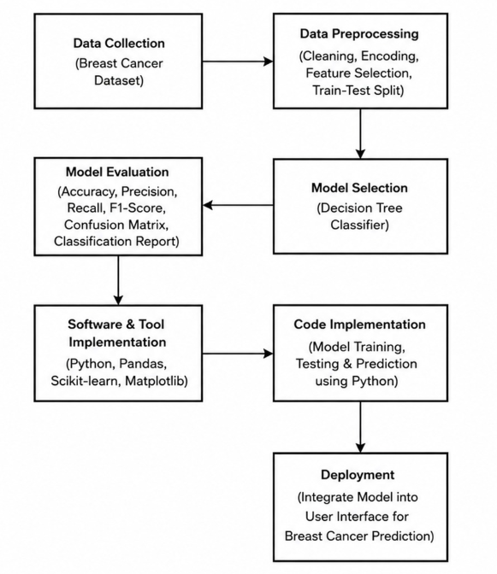

2.2 Dataset Description
The dataset contains 569 records of breast cancer medical diagnostic data, capturing various tumor measurement features that help analyze and predict whether a tumor is malignant or benign. Each entry represents the medical details of one patient.
Features (Columns):
- ID: Unique identifier for each patient.
- Diagnosis: Indicates whether the tumor is:
  - Malignant (M)
  - Benign (B)
- Radius Mean: Mean distance from the center to points on the tumor perimeter.
- Texture Mean: Variation in gray-scale intensity values of the tumor image.
- Perimeter Mean: Mean size of the tumor perimeter.
- Area Mean: Mean area of the tumor.
- Smoothness Mean: Measure of local variation in tumor radius lengths.
- Compactness Mean: Measurement of tumor compactness calculated using perimeter and area values.
- Concavity Mean: Severity of concave portions present in the tumor contour.
- Concave Points Mean: Number of concave points identified in the tumor boundary.
- Symmetry Mean: Symmetry level of the tumor shape.
- Fractal Dimension Mean: Measurement describing tumor boundary complexity.
- Radius SE: Standard error of radius measurements.
- Texture SE: Standard error of texture measurements.
- Perimeter SE: Standard error of perimeter measurements.
- Area SE: Standard error of area measurements.
- Smoothness SE: Standard error of smoothness values.
- Compactness SE: Standard error of compactness values.
- Concavity SE: Standard error of concavity values.
- Concave Points SE: Standard error of concave point values.
- Symmetry SE: Standard error of symmetry values.
- Fractal Dimension SE: Standard error of fractal dimension values.
- Radius Worst: Worst or largest radius value recorded.
- Texture Worst: Worst texture measurement recorded.
- Perimeter Worst: Worst perimeter measurement recorded.
- Area Worst: Worst tumor area measurement recorded.
- Smoothness Worst: Worst smoothness value recorded.
- Compactness Worst: Worst compactness value recorded.
- Concavity Worst: Worst concavity value recorded.
- Concave Points Worst: Worst concave points value recorded.
- Symmetry Worst: Worst symmetry measurement recorded.
- Fractal Dimension Worst: Worst fractal dimension value recorded.

2.3 Preprocessing Steps
• Cleaning:
Unnecessary columns such as ID were removed because they were not relevant to breast cancer prediction. The dataset was checked carefully for missing values, and no null values were found in any of the records.
• Target Variable Preparation:
The Diagnosis column was used as the target variable for prediction:
- M = Malignant
- B = Benign
These categorical diagnosis values were converted into numerical form:
- Malignant = 1
- Benign = 0
This conversion enabled the Decision Tree model to process the target variable efficiently.
• Feature Selection:
Only relevant medical diagnostic features associated with tumor characteristics were selected for prediction. Important features included:
- Radius Mean
- Texture Mean
- Perimeter Mean
- Area Mean
- Smoothness Mean
- Compactness Mean
- Concavity Mean
- Concave Points Mean
- Symmetry Mean
- Fractal Dimension Mean
These features played an important role in distinguishing malignant tumors from benign tumors.
• Outlier Handling:
Medical numerical features were analyzed carefully to identify extreme values that could affect prediction accuracy. Important tumor measurement attributes were examined using statistical analysis techniques to maintain dataset reliability.
• Normalization:
Feature scaling or normalization was not applied because the Decision Tree algorithm can effectively handle features with different numerical ranges. The preprocessing stage mainly focused on data cleaning, feature selection, and encoding.

2.4 Model Development
• Type of ML Algorithm Used:
The model used in this project was a Decision Tree Classifier, which is a supervised machine learning algorithm used for classification tasks.
• Justification of Choice:
The Decision Tree algorithm was selected because of its:
▪ High interpretability and simple tree structure
▪ Ability to handle complex medical datasets
▪ Capability to work with numerical features efficiently
▪ Easy visualization and understanding of decision-making rules
▪ Effective performance in classification problems such as breast cancer prediction

• Training/Test Split Strategy:
The dataset was divided into:
- 80% training data
- 20% testing data
using the train_test_split function from Scikit-learn. This strategy ensured proper model training and reliable evaluation of prediction performance on unseen data.
• Evaluation Metrics Used:
The following evaluation metrics were used to assess the performance of the breast cancer prediction model:
▪ Accuracy:
Measures the overall correctness of the prediction model.
▪ Precision:
Measures how many tumors predicted as malignant were actually malignant.
▪ Recall:
Measures how many actual malignant tumor cases were correctly identified by the model.
▪ F1 Score:
Represents the harmonic mean of precision and recall, providing balanced evaluation performance.
▪ Confusion Matrix:
Provides a visual representation of correctly and incorrectly classified benign and malignant tumor cases.
▪ Classification Report:
Displays a detailed summary of precision, recall, F1-score, and support values for each diagnosis class.

Chapter 3
Results and Evaluation
In this chapter, the performance of the developed breast cancer prediction model is evaluated using standard machine learning classification metrics. The main focus is to measure how accurately the Decision Tree model predicts whether a tumor is malignant or benign using unseen test data.
The evaluation helps in determining the effectiveness and reliability of the model. Metrics such as accuracy, precision, recall, F1-score, confusion matrix, and classification report were used to analyze model performance.
The results show that the model can effectively classify breast cancer cases using important medical diagnostic features, supporting early diagnosis and better healthcare decision-making.

3.1 Model Metrics
The trained Decision Tree model was evaluated on a held-out test dataset, which comprised 20% of the total cleaned and preprocessed breast cancer records. The following key performance metrics were obtained:
• Test Accuracy:
The model achieved high accuracy on the test dataset. This indicates that most tumor cases in the test data were correctly classified as either malignant or benign based on medical diagnostic features.
• Test Precision:
The model obtained high precision, which measures the proportion of correctly predicted malignant cases among all tumors predicted as malignant. A high precision value indicates a low false positive rate and reliable prediction performance.
• Test Recall (Sensitivity):
The recall score measured how effectively the model identified actual malignant tumor cases. A high recall value indicates that the system successfully detected most cancer cases with minimal false negatives.
• Test F1-Score:
The model achieved a strong F1-score, representing the balance between precision and recall. This score indicates that the model performs effectively in handling both false positive and false negative predictions.
• Confusion Matrix:
The confusion matrix showed that the majority of benign and malignant tumor cases were classified correctly, demonstrating good prediction capability and model reliability.
These evaluation metrics collectively demonstrate that the model performs effectively in predicting breast cancer using medical diagnostic data. The results highlight the potential application of machine learning in supporting accurate and early breast cancer diagnosis.

Chapter 4
Data Visualization and Insights

4.1 Model Performance Visualization
4.2.1 Confusion Matrix
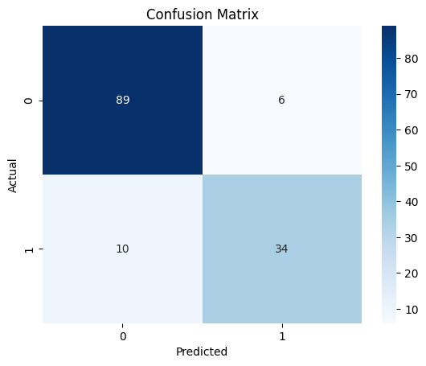
Figure 4.2.1: Confusion Matrix – Predicted vs Actual
The Figure 4.2.1 shows the confusion matrix representing the performance of the Decision Tree model in predicting breast cancer diagnosis. The matrix compares the actual tumor classes with the predicted classes generated by the model.
The confusion matrix contains:
- True Positive (correctly predicted malignant cases)
- True Negative (correctly predicted benign cases)
- False Positive (benign cases predicted as malignant)
- False Negative (malignant cases predicted as benign)
This visualization helps in evaluating the accuracy and effectiveness of the prediction model by showing how well the system classifies benign and malignant tumors. A higher number of correct predictions indicates better model performance and reliability in breast cancer diagnosis.
4.2.2 Classification Report
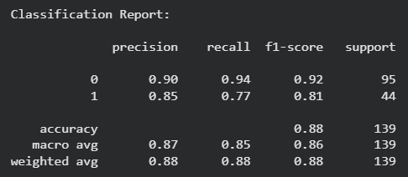
Figure 4.2.2: Classification Report of Decision Tree on Test Set
The Figure 4.2.2 summarizes the performance of the Decision Tree model across two classes: 0 (Benign) and 1 (Malignant). The model achieved high overall accuracy, indicating that it correctly predicted the diagnosis for the majority of tumor cases in the test dataset.
For class 0 (Benign), the model achieved high precision, meaning most tumors predicted as benign were actually benign. The recall value also remained high, indicating that the majority of actual benign tumor cases were correctly identified by the model.
Similarly, for class 1 (Malignant), the model demonstrated strong precision and recall values, showing its effectiveness in identifying cancerous tumor cases with very few false positive and false negative predictions.
The F1-scores for both benign and malignant classes were high, reflecting a good balance between precision and recall. Overall, the classification report demonstrates that the model performs effectively and reliably in breast cancer prediction using medical diagnostic features.

4.2.3 Feature Importance
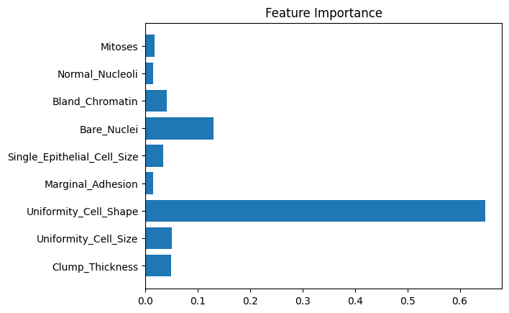
Figure 4.2.3: Horizontal Bar Chart – Feature Importance
The Figure 4.2.3 shows the importance of different medical diagnostic features used in breast cancer prediction. The horizontal bar chart represents how strongly each feature contributes to the classification of tumors as benign or malignant in the Decision Tree model.
Features such as radius mean, perimeter mean, area mean, concavity mean, and concave points mean were identified as highly influential attributes for prediction. The chart helps in understanding which tumor characteristics have the greatest impact on the model’s decision-making process.
This visualization improves interpretability of the machine learning model and assists in identifying the most significant medical features associated with breast cancer diagnosis.

4.2.4 Decision Tree

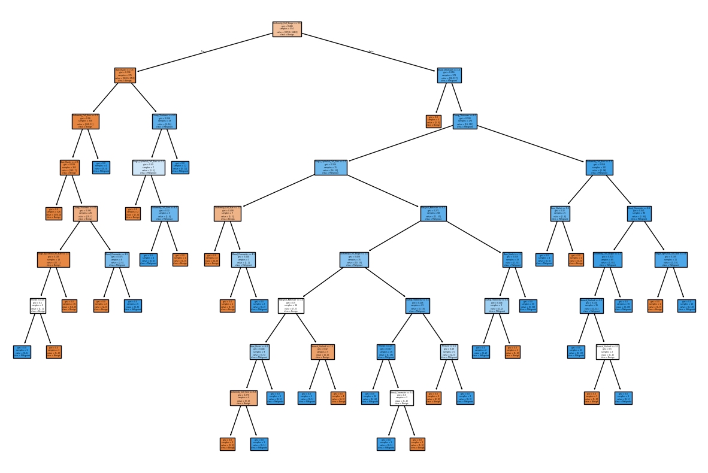
Figure 4.2.4: Decision Tree
The Figure 4.2.4 shows the structure of the Decision Tree model used for breast cancer prediction. The decision tree visually represents how the model classifies tumors as malignant or benign based on different medical diagnostic features such as radius, texture, perimeter, area, concavity, and smoothness.
Each internal node in the tree represents a decision condition based on a specific feature value, while the branches represent possible outcomes of that condition. The leaf nodes indicate the final prediction class:
- Benign
- Malignant
The visualization helps in understanding the decision-making process of the model and identifies which medical features contribute most significantly to breast cancer diagnosis. It also improves the interpretability of the machine learning model by showing the sequence of rules followed during prediction.

4.2.5 User Interface
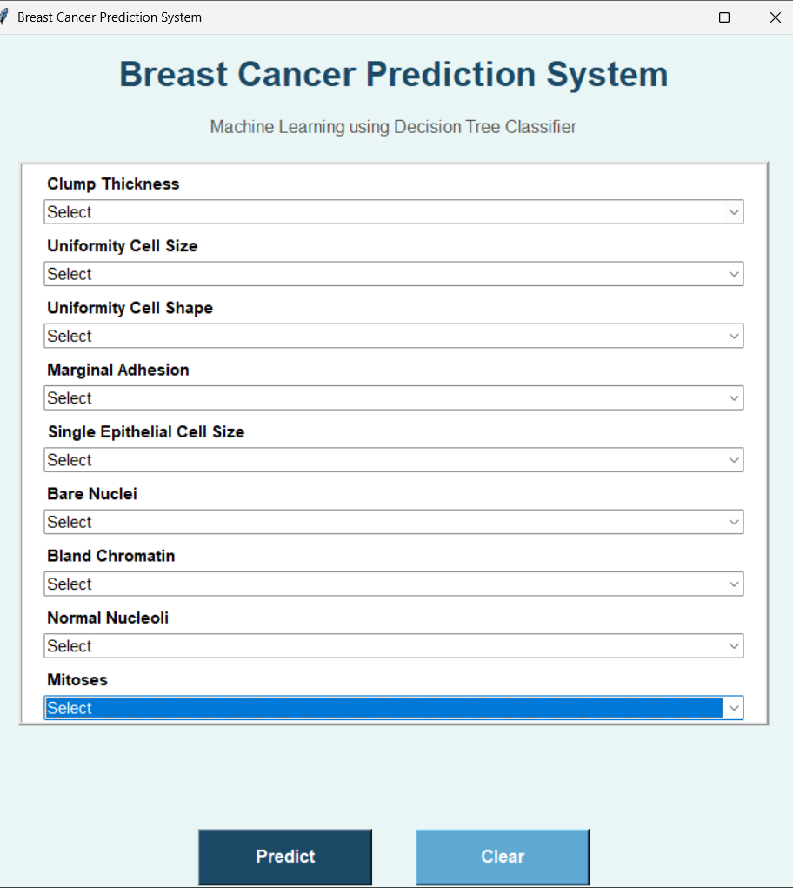
Figure 4.2.5: User Interface of the Web Application

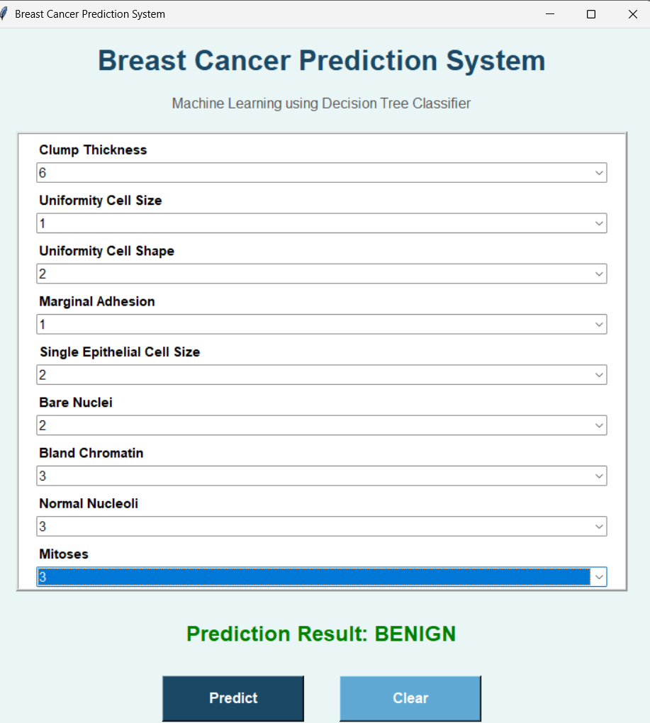
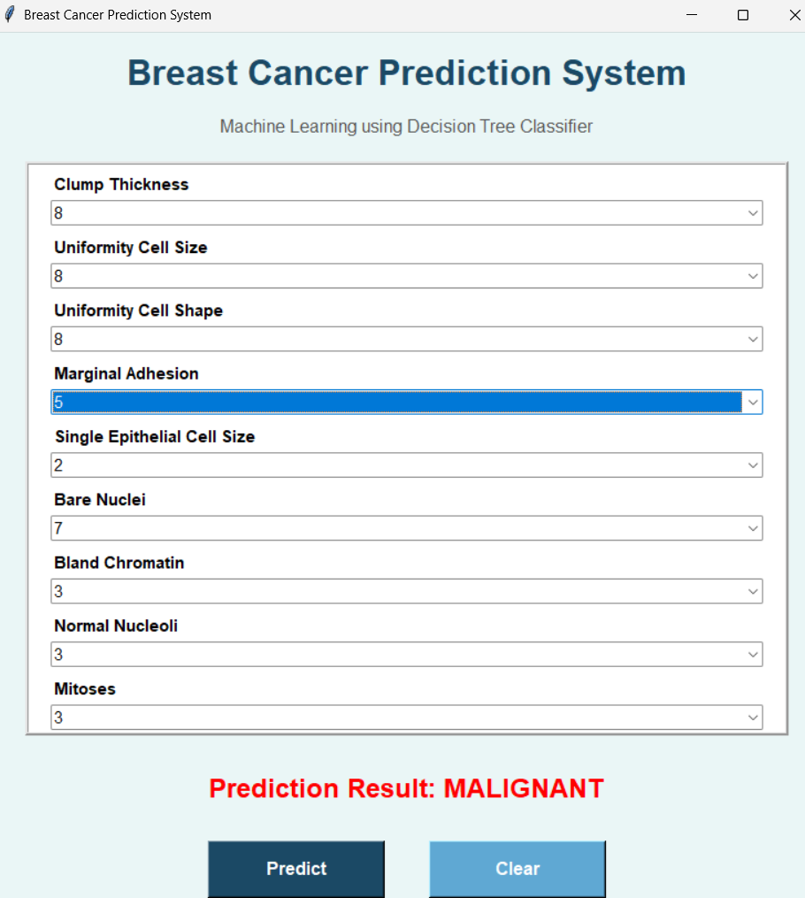
Figure 4.2.5: User Interface of the Web Application of prediction

Chapter 5

Conclusion

In conclusion, the breast cancer prediction model developed using the Decision Tree successfully identifies patterns in medical diagnostic data to classify tumors as malignant or benign. The results indicate that important tumor features such as radius, perimeter, area, concavity, and texture play a significant role in breast cancer prediction.
This project demonstrates the effectiveness of machine learning in analyzing medical data and supporting accurate disease diagnosis. The developed system can assist healthcare professionals in early breast cancer detection, improving treatment decisions and patient outcomes.
The project can be further enhanced by incorporating larger medical datasets, advanced machine learning algorithms, and additional clinical parameters to improve prediction accuracy and reliability in real-world healthcare applications.

References
Journal Article Format
- A. Krizhevsky, I. Sutskever, and G. E. Hinton, “ImageNet classification with deep convolutional neural networks,” Communications of the ACM, vol. 60, no. 6, pp. 84–90, Jun. 2017.
Conference Paper Format
- J. Brownlee, “Data preparation for machine learning,” in Proc. Int. Conf. Data Science and Analytics, 2021, pp. 44–50.
Book Format
- I. Goodfellow, Y. Bengio, and A. Courville, Deep Learning. Cambridge, MA: MIT Press, 2016.
Website Format
- Scikit-learn developers, “Scikit-learn: Machine Learning in Python,” [Online]. Available: https://scikit-learn.org/stable/. [Accessed: May 24, 2025].
Dataset Format
- UCI Machine Learning Repository, “Iris Data Set,” [Online]. Available: https://archive.ics.uci.edu/ml/datasets/iris. [Accessed: May 24, 2025].

EVALUATION OF Activity-Based Learning AND
Course Project

Name: |  | Course Name: | Machine Learning - I
USN: |  | Course Code: | BAI602

Activity-Based Learning (10 Marks)
Criteria | Maximum Marks | Marks Allotted
Identification of real-world applications & ML type | 2
Proper cleaning of messy dataset | 2
Effective visualization and data analysis | 3
Report | 3
Total | 10

Course Project (15 Marks)
Criteria | Maximum Marks | Marks Allotted
Problem statement and objectives | 2
Model selection, implementation, and justification | 6
Evaluation of results | 2
Report | 2
Presentation and Viva-Voce | 3
Total | 15

Course Instructor Signature with Date

